There are several different invoice reporting functions in QAD.
All of them show you the invoices which have been already posted.
It depends what you need to see and what kind of report you need.
Try to go via below functions to find the best one for you.
Each of them have different options of showing columns = of showing information.

7.13.8 Invoice History Report
I like to use this one. Below you can see what are the most important columns for me.
Some columns are hidden here as well.
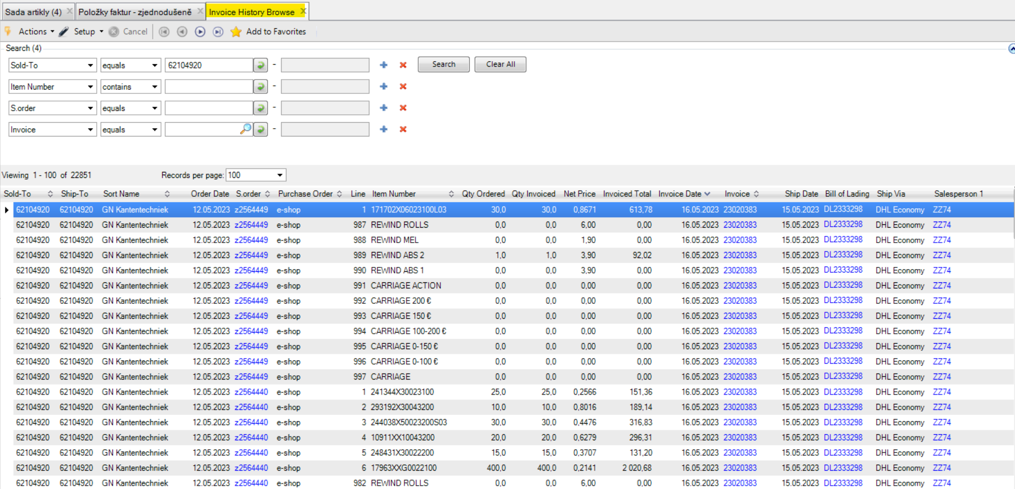

Adding of the columns = by using right click mouse on the bar (anywhere) + choose Columns.
Hidding of the columns = by using right click mouse on the bar (mark particular column) + choose Hide Columns.
Automatically full sized column = by using right click mouse on the baer (anywhere) + choose Autosize column
It works like this everywhere in QAD.
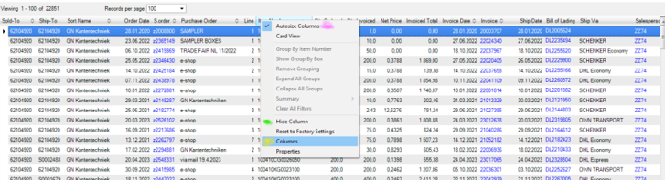
Below you can choose/click required boxes/columns.
You can move the columns by left mouse click and move the column to the desired location. By dragging.
+ SAVE
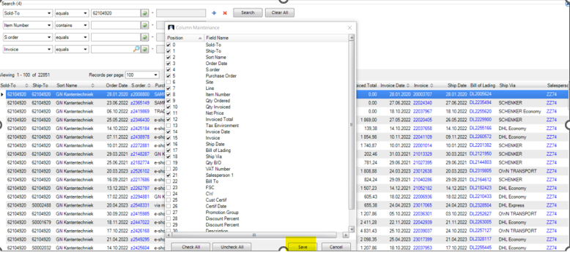

27.50.21 Invoice Lines Browse – simple
I also like this function. In comparison with above one there is a field Remark where I can see my comments about the recipients.
But what I miss her eis Quantity Ordered.
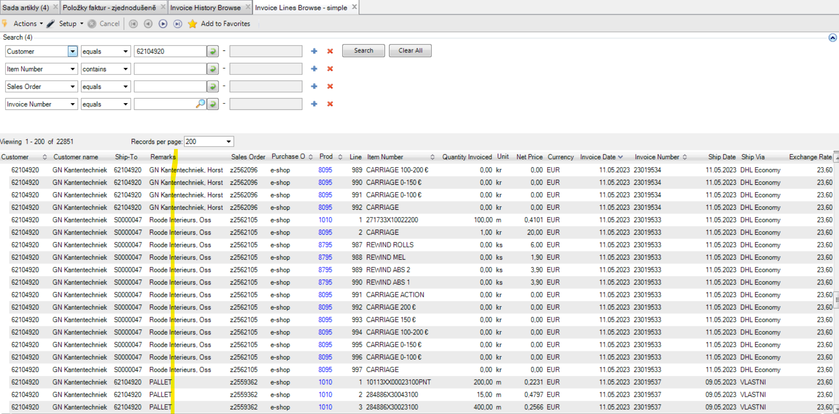

Each function have a little more and a little less.
Other functions you can check as below.

51.2.4.17 Invoice Lines Browse II
Can be very well used. I think this function is very similar to 27.50.21.

27.50.1 Invoice Browse
Contains more information for accountant.

